# Lab – 09 Namespace and Scope, Module, Packages, Try Except Structure

Tasks:

1. Given the following directory structure of package and modules with source codes of some of the files are given below:



**Create a file called program_q1.py first** and then create a folder called calculation in **Visual Studio Code** and the other corresponding file as shown in the above diagram.

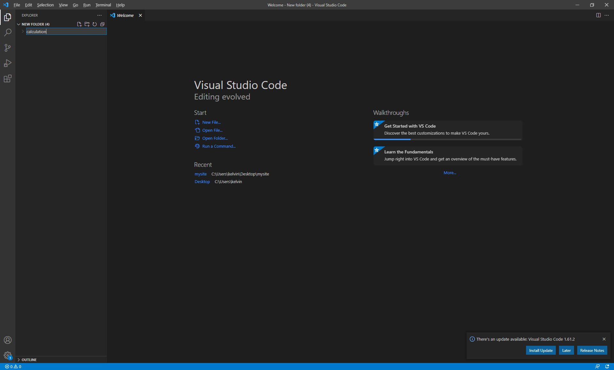

1.

2.

**circle.py**

import math

def circle( radius ):

area = radius ** 2 * math.pi

surface_area = 4 * math.pi * radius ** 2

volume = 4 / 3 * math.pi * radius ** 3

return area, surface_area, volume

print ("The following codes are used to test the circle library")

area, surface_area, volume = circle(5)

print ("Area of circle is", area)

print ("Surface area of sphere is", surface_area)

print ("Volume of sphere is", volume)

**rectangle.py**

def rectangle( length, width, height ):

area = length * width

surface_area = ( length * width + length * height + width * height ) * 2

volume = length * width * height

return area, surface_area, volume

print ("The following codes are used to test the rectangle library")

area, surface_area, volume = rectangle(2,4,6)

print ("Area of rectangle (length * width) is", area)

print ("Surface area of rectangle is", surface_area)

print ("Volume of rectangle is", volume)

**program_q1.py**

import calculation

l = float ( input ( "Enter the length of rectangle: " ) )

w = float ( input ( "Enter the width of rectangle: " ) )

h = float ( input ( "Enter the height of rectangle: " ) )

area_rectangle, surface_area_rectangle, volume_rectangle = rectangle ( l, w, h )

1. Execute the circle and rectangle module directly and note the output of circle and rectangle modules in calculation package. (No need to answer this question)
2. The module program.py is now going to use both circle.py and rectangle.py modules in calculation package. **Modify program_q1.py only** so that program_q1.py can make use of rectangle module in calculation package.

Sample Output:

The following codes are used to test the rectangle library

Area of rectangle (length * width) is 8

Surface area of rectangle is 88

Volume of rectangle is 48

Enter the length of rectangle: 2

User’s input

Enter the width of rectangle: 2

Enter the height of rectangle: 2

Area of rectangle (length * width) is 4.0

Surface area of rectangle is 24.0

Volume of rectangle is 8.0

Answer:

import calculation.rectangle

l = float ( input ( "Enter the length of rectangle:" ) )

w = float ( input ( "Enter the width of rectangle:" ) )

h = float ( input ( "Enter the height of rectangle:" ) )

area_rectangle, surface_area_rectangle, volume_rectangle = calculation.rectangle.rectangle ( l, w, h )

print ("Area of rectangle (length * width) is", area_rectangle)

print ("Surface area of rectangle is", surface_area_rectangle)

print ("Volume of rectangle is", volume_rectangle)

1. In addition to the functions of calculating the area, surface area and volume of rectangle, the testing codes in rectangle module are also executed. Try to **modify rectangle module only** so that the testing codes inside rectangle module will not be executed when called by another module, while those codes will still be executed when user execute the rectangle module.

Sample Output:

Enter the length of rectangle: 2

User’s input

Enter the width of rectangle: 2

Enter the height of rectangle: 2

Area of rectangle (length * width) is 4.0

Surface area of rectangle is 24.0

Volume of rectangle is 8.0

Answer:

def rectangle( length, width, height ):

area = length * width

surface_area = ( length * width + length * height + width * height ) * 2

volume = length * width * height

return area, surface_area, volume

if __name__ == "__main__":

print ("The following codes are used to test the rectangle library")

area, surface_area, volume = rectangle(2,4,6)

print ("Area of rectangle (length * width) is", area)

print ("Surface area of rectangle is", surface_area)

print ("Volume of rectangle is", volume)

1. **Modify program_q1.py** **only** to include the circle module to calculate the area of circle, surface area and volume of sphere.

Sample Output:

The following codes are used to test the circle library

Area of circle is 78.53981633974483

Surface area of sphere is 314.1592653589793

Volume of sphere is 523.5987755982989

Enter the length of rectangle: 2

User’s input

Enter the width of rectangle: 2

Enter the height of rectangle: 2

Enter the radius of circle: 2

Area of rectangle (length * width) is 4.0

Surface area of rectangle is 24.0

Volume of rectangle is 8.0

Area of circle is 12.566370614359172

Surface area of sphere is 50.26548245743669

Volume of sphere is 33.510321638291124

Answer:

import calculation.rectangle

import calculation.circle

l = float ( input ( "Enter the length of rectangle: " ) )

w = float ( input ( "Enter the width of rectangle: " ) )

h = float ( input ( "Enter the height of rectangle: " ) )

r = float ( input ( "Enter the radius of circle: " ) )

area_rectangle, surface_area_rectangle, volume_rectangle = calculation.rectangle.rectangle ( l, w, h )

area_circle, surface_area_sphere, volume_sphere = calculation.circle.circle(r)

print ("Area of rectangle (length * width) is", area_rectangle)

print ("Surface area of rectangle is", surface_area_rectangle)

print ("Volume of rectangle is", volume_rectangle)

print ("Area of circle is", area_circle)

print ("Surface area of sphere is", surface_area_sphere)

print ("Volume of sphere is", volume_sphere)

1. **Modify circle module only** so that testing codes will not be executed when called by program.py module.

Sample Output:

Enter the length of rectangle: 2

User’s input

Enter the width of rectangle: 2

Enter the height of rectangle: 2

Enter the radius of circle: 2

Area of rectangle (length * width) is 4.0

Surface area of rectangle is 24.0

Volume of rectangle is 8.0

Area of circle is 12.566370614359172

Surface area of sphere is 50.26548245743669

Volume of sphere is 33.510321638291124

Answers:

import math

def circle( radius ):

area = radius ** 2 * math.pi

surface_area = 4 * math.pi * radius ** 2

volume = 4 / 3 * math.pi * radius ** 3

return area, surface_area, volume

if __name__ == "__main__":

print ("The following codes are used to test the circle library")

area, surface_area, volume = circle(5)

print ("Area of circle is", area)

print ("Surface area of sphere is", surface_area)

print ("Volume of sphere is", volume)

1. **Modify program_q1.py only** using try and except so that the program can handle non-numeric input gracefully.

Sample Output:

Enter the length of rectangle: a

Ask user for length value again

Input a numeric value again

Enter the length of rectangle: 2

Enter the width of rectangle: a

Input a numeric value again

Ask user for width value again

Enter the width of rectangle: 2

Enter the height of rectangle: a

Input a numeric value again

Ask user for height value again

Enter the height of rectangle: 2

Enter the radius of circle: a

Input a numeric value again

Ask user for radius value again

Enter the radius of circle: 2

Area of rectangle (length * width) is 4.0

Surface area of rectangle is 24.0

Volume of rectangle is 8.0

Area of circle is 12.566370614359172

Surface area of sphere is 50.26548245743669

Volume of sphere is 33.510321638291124

Answers:

import calculation.rectangle

import calculation.circle

while True:

try:

if "l" not in locals():

l = float ( input ( "Enter the length of rectangle: " ) )

if "w" not in locals():

w = float ( input ( "Enter the width of rectangle: " ) )

if "h" not in locals():

h = float ( input ( "Enter the height of rectangle: " ) )

if "r" not in locals():

r = float ( input ( "Enter the radius of circle: " ) )

break

except ValueError:

print ( "Input a numeric value again" )

area_rectangle, surface_area_rectangle, volume_rectangle = calculation.rectangle.rectangle ( l, w, h )

area_circle, surface_area_sphere, volume_sphere = calculation.circle.circle(r)

print ("Area of rectangle (length * width) is", area_rectangle)

print ("Surface area of rectangle is", surface_area_rectangle)

print ("Volume of rectangle is", volume_rectangle)

print ("Area of circle is", area_circle)

print ("Surface area of sphere is", surface_area_sphere)

print ("Volume of sphere is", volume_sphere)

1. Given the following directory structure of package and modules. Source code of program_q2.py is given below:



**program_q2.py**

# You are not allowed to modify all the codes in this file

import os

import os_command.directory

def main():

list_directory = os_command.directory.get_directory_list(os.getcwd())

list_file = os_command.directory.get_file_list(os.getcwd())

print("List of directories in path", os.getcwd())

for i in list_directory:

print (i)

print("List of files in path", os.getcwd())

for i in list_file:

print (i)

if __name__ == "__main__":

main()

Display all the directories and files in ascending order of current folder by completing the **directory.py** module. A sample output is given below.

Sample Output:

List of directories in path C:\Users\Kelvin\Source Files

calculation

os_command

List of files in path C:\Users\Kelvin\Source Files

program_q1.py

program_q2.py

Answers:

import os

def get_directory_list(path):

directory_list = list()

content = os.scandir(path)

for item in content:

if os.path.isdir(item):

directory_list.append(item.name)

directory_list.sort()

return directory_list

def get_file_list(path):

file_list = list()

content = os.scandir(path)

for item in content:

if os.path.isfile(item):

file_list.append(item.name)

file_list.sort()

return file_list

Hints: Create an empty list to store every items from the contents of os.scandir() returns.

By calling os.scandir() function, it contains a list of DirEntry objects (More precisely speaking it should be ScandirIterator object) instead of list of strings. DirEntry objects cannot be sorted even if they are put into an ordinary list. To obtain the string of directory name or file name from the DirEntry object, use **item.name** property, where item is every items in os.scandir() returns.

1. Troubleshoot the following program. The following program is intended to find out the sum, average, minimum and maximum of user provided number of random numbers generated.

import random

def display(list_numbers):

print ("Sum =", sum(list_numbers))

print ("Average =", sum(list_numbers)/len(list_numbers))

print ("Minimum =", min(list_numbers))

print ("Maximum =", max(list_numbers))

def create_random_number(no_of_random_numbers):

list_random_numbers = list()

for i in range(1, no_of_random_numbers+1):

list_random_numbers.append( random.randint(1, 100) )

print (f"Number {i} is {list_random_numbers[i]}")

def main():

no_of_random_numbers = input("Number of random numbers: ")

list_random_number = create_random_number(no_of_random_numbers)

display(list_random_number)

if __name__ == "__main__":

main()

Sample Output:

Number of random numbers: 5

Number 0 is 59

Number 1 is 19

Number 2 is 95

Number 3 is 46

Number 4 is 89

Sum = 308

Average = 61.6

Minimum = 19

Maximum = 95

Answer:

import random

def display(list_numbers):

print ("Sum =", sum(list_numbers))

print ("Average =", sum(list_numbers)/len(list_numbers))

print ("Minimum =", min(list_numbers))

print ("Maximum =", max(list_numbers))

def create_random_number(no_of_random_numbers):

list_random_numbers = list()

for i in range(no_of_random_numbers):

list_random_numbers.append( random.randint(1, 100) )

print (f"Number {i} is {list_random_numbers[i]}")

return list_random_numbers

def main():

no_of_random_numbers = int(input("Number of random numbers: "))

list_random_number = create_random_number(no_of_random_numbers)

display(list_random_number)

if __name__ == "__main__":

main()

1. Troubleshoot the following program. The following program is intended to calculate the roots of quadratic equation. A sample output is shown below:

def quadratic(a, b, c):

output = ""

if a==0:

output = "This is not a quadratic equation"

else:

discriminant = (b * b - 4 * a * c)

if discriminant > 0: # two roots

x1= (-b + discriminant ** 0.5) / (2 * a)

x2= (-b - discriminant ** 0.5) / (2 * a)

output = "2 roots, x1 = "+str(x1)+", x2 = "+str(x2)

elif discriminant == 0: # one root:

x= -b / (2 * a)

output = "1 root, x ="+str(x)

else: # no roots

output = "No real roots"

def main():

print (quadrtic(3,-4, 1))

print (quadratic(1,-2))

if __name__ == "__main__":

main()

Output:

2 roots, x1 = 1.0, x2 = 0.3333333333333333

1 root, x =1.0

Answer:

def quadratic(a, b, c):

output = ""

if a==0:

output = "This is not a quadratic equation"

else:

discriminant = (b * b - 4 * a * c)

if discriminant > 0: # two roots

x1= (-b + discriminant ** 0.5) / (2 * a)

x2= (-b - discriminant ** 0.5) / (2 * a)

output = "2 roots, x1 = "+str(x1)+", x2 = "+str(x2)

elif discriminant == 0: # one root:

x= -b / (2 * a)

output = "1 root, x ="+str(x)

else: # no roots

output = "No real roots"

return output

def main():

print (quadratic(3,-4, 1))

print (quadratic(1,-2, 1))

if __name__ == "__main__":

main()

1. Troubleshoot the following program. The following program is intended to accumulate all prime numbers in between 1 and user input n. Your program should display all prime numbers from 1 to n and the sum of these numbers. A sample output is shown below:

def is_prime_number(number):

if number < 2:

return False

for divisor in range (2, number):

if number % divisor == 0:

break

else:

return True

return False

def main():

n = int(input("Input the value n: "))

total = 0

output_string = ""

print("The prime numbers are:")

for i in range(1,n):

if is_prime_number(i):

output_string += str(i)+", "

total+=i

print (output_string)

print("Sum of all prime numbers within 1 and",n,"=",total)

if __name__ == "__main__":

main()

Output:

Input the value n: 101

User’s input

The prime numbers are:

2, 3, 5, 7, 11, 13, 17, 19, 23, 29, 31, 37, 41, 43, 47, 53, 59, 61, 67, 71, 73, 79, 83, 89, 97, 101

Sum of all prime numbers within 1 and 100 = 1161

Answer:

def is_prime_number(number):

if number < 2:

return False

for divisor in range (2, number):

if number % divisor == 0:

break

else:

return True

return False

def main():

n = int(input("Input the value n: "))

output_string = ""

total=0

print("The prime numbers are:")

for i in range(1,n+1):

if is_prime_number(i):

output_string += str(i)+", "

total+=i

print (output_string)

print("Sum of all prime numbers within 1 and",n,"=",total)

if __name__ == "__main__":

main()

1. Troubleshoot the following program. The following function is intended to loop through and remove all even numbers from the numbers list, then the number list should be printed out with the items displayed in ascending order.

def remove_even_numbers(numbers):

for i in numbers:

if i%2==0:

numbers.remove(i)

numbers.sort()

print (numbers)

def main():

numbers = [

951, 402, 984, 651, 360, 69, 408, 319, 601, 485, 980, 507, 725,

547, 544, 615, 83, 165, 141, 501, 263, 617, 865, 575, 219, 390,

984, 592, 236, 105, 942, 941, 386, 462, 47, 418, 907, 344, 236,

375, 823, 566, 597, 978, 328, 615, 953, 345, 399, 162, 758, 219,

918, 237, 412, 566, 826, 248, 866, 950, 626, 949, 687, 217, 815,

67, 104, 58, 512, 24, 892, 894, 767, 553, 81, 379, 843, 831, 445,

742, 717, 958, 609, 842, 451, 688, 753, 854, 685, 93, 857, 440,

380, 126, 721, 328, 753, 470, 743, 527

]

remove_even_numbers(numbers)

if __name__ == "__main__":

main()

Output:

[47, 67, 69, 81, 83, 93, 105, 141, 165, 217, 219, 219, 237, 263, 319, 345, 375, 379, 399, 445, 451, 485, 501, 507, 527, 547, 553, 575, 597, 601, 609, 615, 615, 617, 651, 685, 687, 717, 721, 725, 743, 753, 753, 767, 815, 823, 831, 843, 857, 865, 907, 941, 949, 951, 953]

Answer:

# your code goes here

def remove_even_numbers(numbers):

i=0

while (i<len(numbers)):

if numbers[i]%2==0:

del numbers[i]

continue

i+=1

numbers.sort()

print (numbers)